News Release 11th June 2007
From: Phillips Publicity
Tel: UK 1460 432090 / 7980 832639
Email: duncanphillips@btinternet.com
www.emiratesartandantiquesfairs.com
www.abudhabiartandantiquesfair.com
www.dubaiartandantiquesfair.com
__________________________________________________________________________________

Leading European Galleries Confirmed
for UAE Art & Antiques Fairs

The Abu Dhabi International Fine Art and Antiques Fair
The Abu Dhabi National Exhibition Centre
Abu Dhabi, UAE
21st – 24th November 2007

The Dubai International Fine Art and Antiques Fair
Dubai International Convention and Exhibition Centre,
Dubai, UAE
12th – 15th December 2007

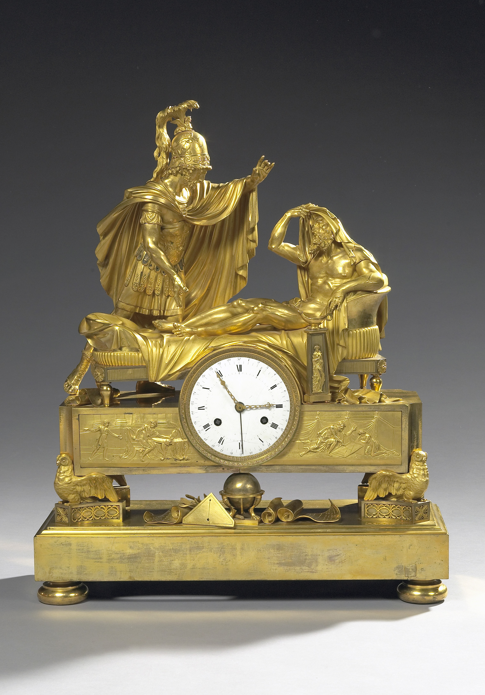
Leading art and antique galleries from across Europe have confirmed their participation in the major international art and antiques fairs to be held in Abu Dhabi and Dubai in 2007.

Galleries from Paris, London, Rome, Vienna, Brussels and Florence will be among those taking part in The Abu Dhabi International Fine Art and Antiques Fair, 21st – 24th November, and The Dubai International Fine Art and Antiques Fair, 12th – 15th December.

Fran Foster, the Fair Director for both events, speaking on behalf of the organisers, Turret Middle East Ltd of Abu Dhabi, commented: ‘I have been delighted with the high level of international support for both events which are now more than 75% allocated to exhibitors and fully on course to becoming major prestige events in the calendar of the international art market. In recent weeks several exhibitors have made private visits to the UAE and have all been particularly impressed by the high level of facilities provided at both exhibition venues, which already host major international events that attract visitors from all over the world.’
An exceptional clock made in Paris, in chiselled and gilded bronze, representing Pericles beside the bed of Anaxagore, by François-Aimé Damerat ( 1781-1819), and Étienne-Louis Forestier (1753 – appr.1821).
Signed on the enamelled dial.
H. 67 cm W. 56 cm D. 20 cm .
Paris, circa 1803 – 1809.
The only other similar example is conserved at the Hermitage in
St. Petersbourg.
To be shown by
Galerie Michel-Guy Chadelaud, Paris.
Price: 250,000 Euros.

A wide spectrum of fine art and antiques will be represented, from ancient art to 17th, 18th, 19th and 20th century furniture, clocks, jewellery, sculpture, ceramics, glass, bronzes, photography, tapestries, Old Masters, contemporary art and Islamic art.

Among the exhibitors taking part will be Galerie Michel-Guy Chadelaud from Paris, who will be taking a large stand of 200 square metres in both fairs to show a wide range of period furniture and paintings; Centro Antiquario Romano di Roberto Parenza from Rome, specialising in Old Master paintings, bronze sculpture and period furniture; Galleria Pasti Bencini from Florence, specialising in Old Masters, 19th and 20th century paintings; Galerie Kevorkian from Paris, specialising in Islamic Art, Ancient Art and Eastern Archaeology; and Galerie St. Jacques from Brussels with contemporary art.

From Vienna, Joseph Schuetz Art & Antiques will be specialising in contemporary art and decorative antiques; Antichia Gran Tour from Rome will show Old Master paintings, European period furniture, bronze and marble sculpture and ceramics; Gladwell & Company from London will show works of art; Renzo Moroni from Rome, will be specialising in Old Master paintings; Casa D'Arte il Borghetto from Milan, has Old Master paintings, furniture, bronzes, and marble sculptures; Farnese Arte from Rome will be showing Old Master paintings, European period furniture, bronze and marble sculpture and ceramics; Luigi Colasanti from Rome will also be specialising in Old Masters, European furniture, bronzes and ceramics; Romana Antichia di Marco Parenza from Rome will show antiques and works of art; and Paola Cipriani from Rome will be showing works of art, fine furniture and the Decorative Arts.

Details of a further 30 Italian, French, German, Swiss and British dealers will also be announced shortly.

Government Patronage
Further details have also been announced of the high level of public support to be given by the respective UAE governments.

The Abu Dhabi International Fine Art and Antiques Fair will take place under the patronage of H.H. Sheikh Sultan bin Tahnoon Al Nahyan, Chairman of the Abu Dhabi Authority for Culture and Heritage.

‘Support from such eminent figures is extremely welcome,’ commented Fran Foster. ‘Their patronage vastly enhances the appeal of both events throughout the Middle East and beyond’.

Details of major sponsorship arrangements will also be announced shortly

Continued…/

Turret Middle East Ltd.
Stand Bookings and Features Operations:
Fran Foster
Mobile: +44 (0)7971 839428
Email: f.foster@turretme.com

PO Box 60629,
ADNEC House
Abu Dhabi,
United Arab Emirates.

PRESS CONTACT: Duncan Phillips
2 Knapp Cottages, High Street, Thorncombe, Dorset TA20 4PQ. UK.
Tel: +44 (0)1460 432090 / 07980 832639. duncanphillips@btinternet.com.

